An easy recipe for a dessert!

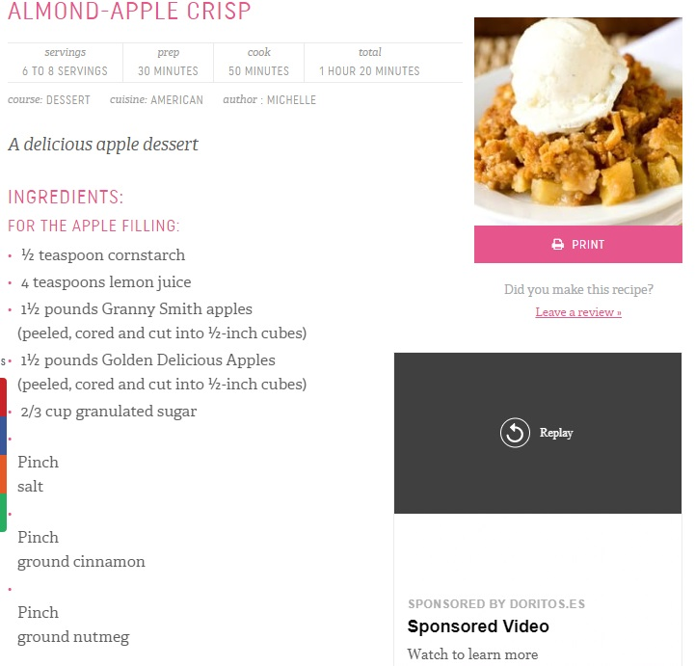

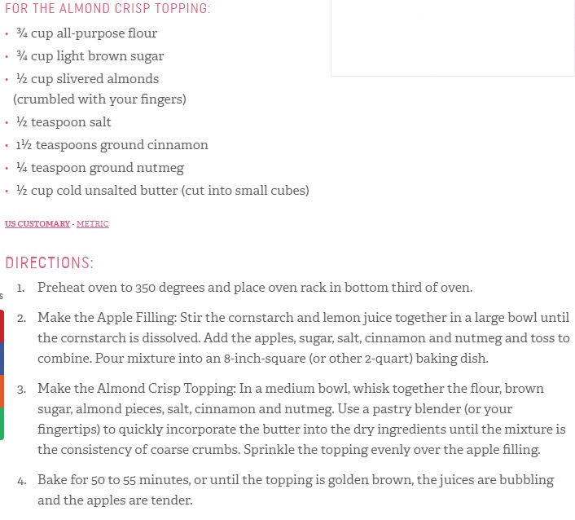

Recipe taken from <https://www.browneyedbaker.com/almond-apple-crisp/>