All about pine trees!

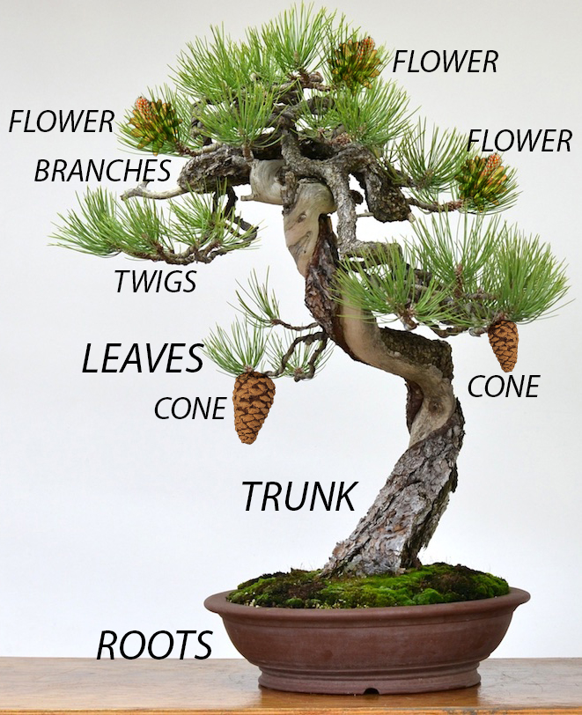
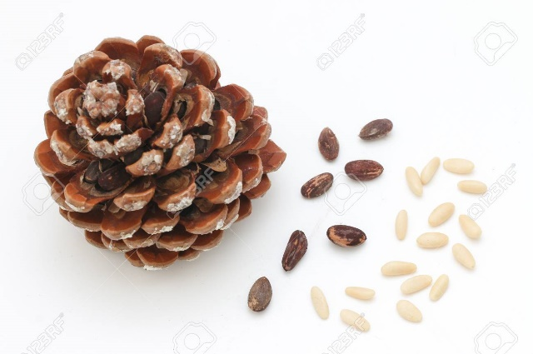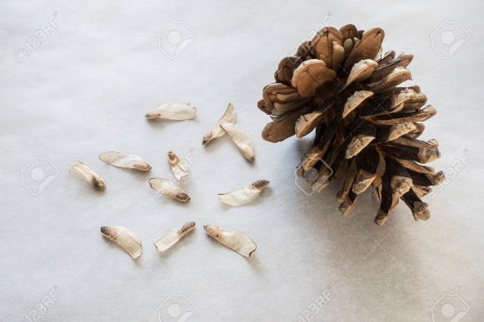
SEEDS
Pine trees are perennial – they don’t lose their leaves in winter.

One tiny seed  Fell from a tree.  It flew, and flew,  And touched the ground  Near the sea.  It missed the leaves,  It missed the trunk,  It missed the leaves,  It missed the sun,  And missed having fun.  It sank and sank,  The earth felt damp,  The light went out,  It went to sleep  Surrounded by ants.  And in its sleep,  Its dreams gave birth,  A root grew deep  Inside the earth,  And out came a sprout. | 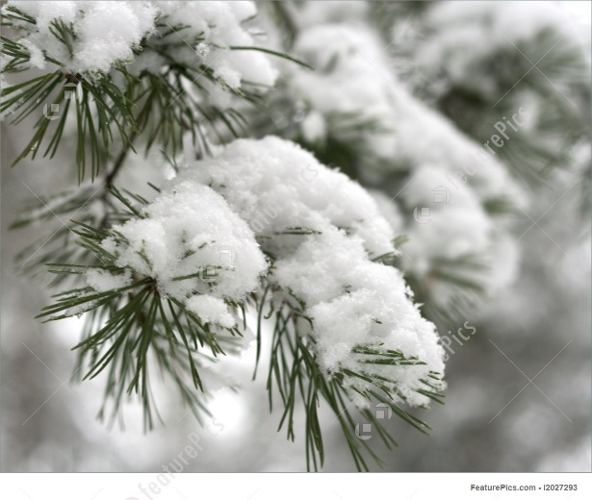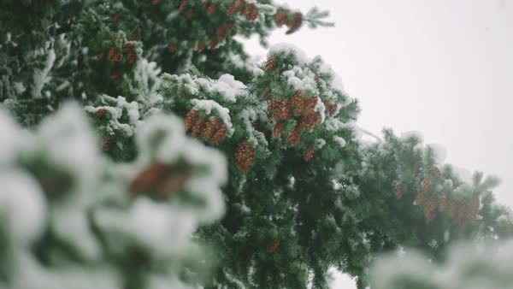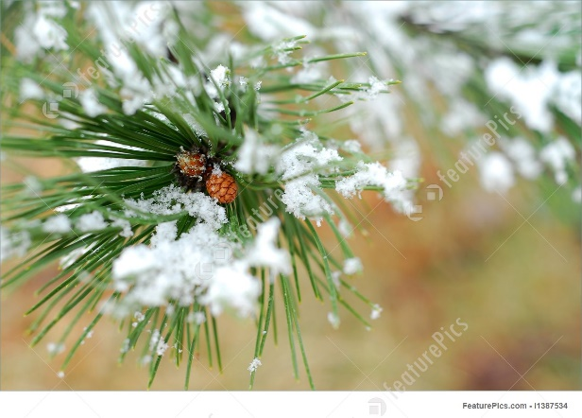
The tiny sprout,  With its new life,  Dreamt of being big  And touch the wind,  And dance in the sky.  It grew and grew,  Its branches flew,  Its roots grew strong,  Its million leaves  Were covered in dew. | 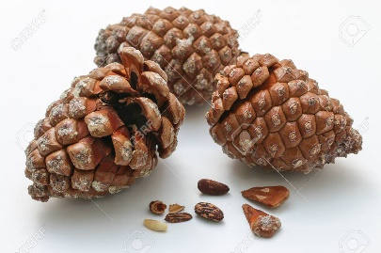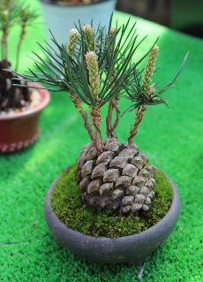  The seed was a tree,  And, near the sea,  From its new fruits,  Touched by the wind,  Fell one tiny seed.

