An easy recipe for a dessert!

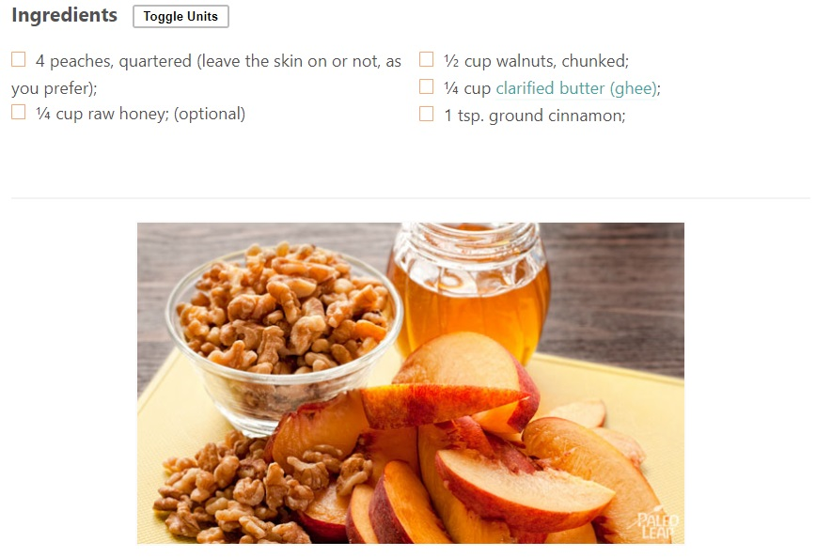

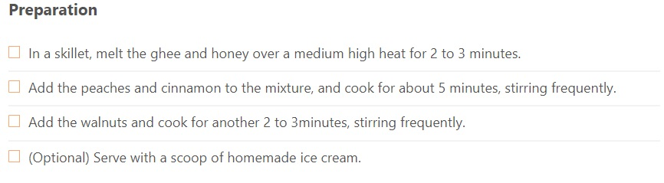

Recipe taken from <https://paleoleap.com/honey-coated-walnuts-peaches/>